2019
BBX Royal Hobart Show
Teachers’ Guide

Students still only $3.50, carers ratio 1:4

Show Dates 2019: 23rd – 26th October

School Day 2019: Wednesday 23rd October
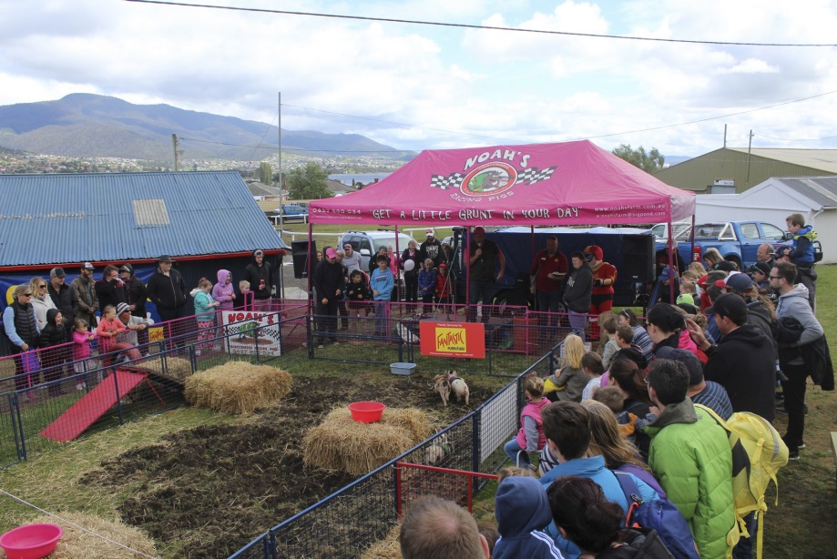


2019 Royal Hobart Show Teachers Guide is available on http://hobartshowground.com.au/royal-hobart-show/education-discovery-2/
Discovery Sheets, colouring competitions and other resources are available for download as well

Contents
- Contents 2
- Entertainment Highlights 3 - 4
- Introduction 5
- Competitions suitable for schools 6
- Curriculum Ideas 7 - 10
- Show Features 11 – 22
- Survival Guide 23 – 25
- Hand Washing Instructions 26
- School Group information form 27
- School Group booking form 28
- Show Map 29
- Map of Showground- school bus drop off 30

Discovery Sheets available for:-
Alpacas | Bullocks
Cavies / Guinea Pigs | Creative Crafts
Dinosaur Petting Zoo | Dogs
Goats | Vintage Machinery
Poultry & Caged Birds | Sheep
The Mercury | Show Word Search
Lumberjacks & Paul Bunyan | Miniature Pigs
Youth Art , Homecrafts, Student Photography competitions now open.
DOWNLOAD FROM www.hobartshowground.com.au


2019 Entertainment Highlights
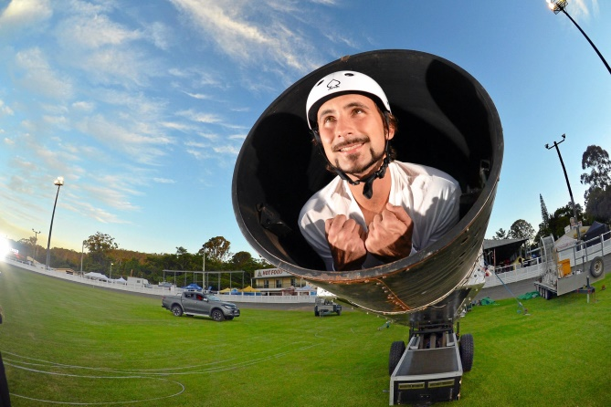
Blast off! Our performer is shot out from our specially designed cannon at over 75kph flying across the arena before landing safely into a net up to 40 meters away. With our performer experiencing up to 6G’s of force on take-off this act is sure to leave audiences on the edge of their seat!
The Human Cannonball
is entertainment at its best! Fun filled enjoyment for all ages.
Noah’s Thoroughbred Racing Pigs
From the bugle race call, through the obstacles, to the last snout in the finishing trough, crowds will be cheering their preferred pig to the end.
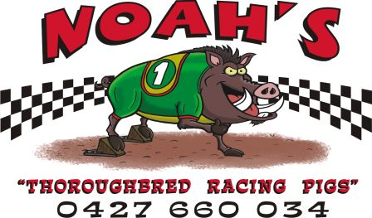
Noah’s Thoroughbred Racing Pigs have been entertaining Australians for over a decade, travelling all over Queensland, New South Wales & Victoria.

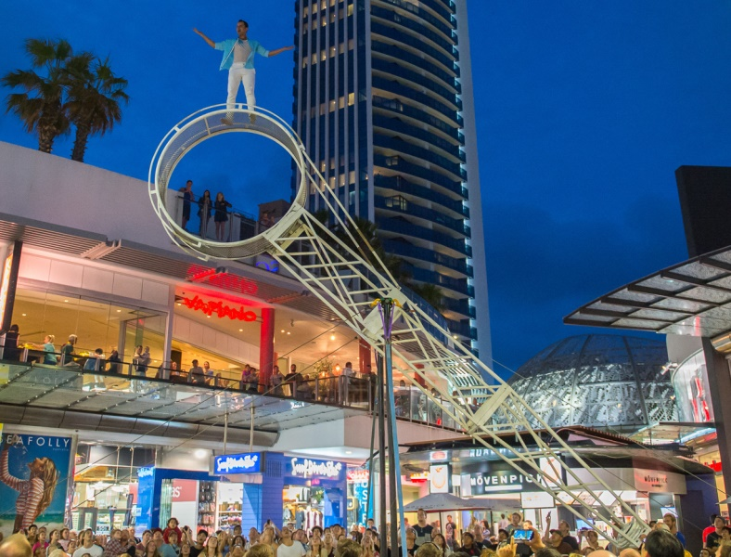
The Wheel of Steel is a thrilling performance where the performer runs, skips and executes acrobatics whilst running in a rotating steel pendulum that reaches a height of 11 metres. This high adrenaline act is performed without the aid of safety nets or wires, making it a truly on the edge of your seat experience.
Wheel of Steel

2019 Entertainment Highlights cont.
In the days before tractors and heavy machinery animals were used to do all of the heavy lifting. This included heavy horses and bullocks. Brian Fish is keeping the tradition alive and is a wealth of information about these magnificent beasts and their contribution to the early colony.
Also featuring at the 2019 Royal Hobart Show

- Charity Children’s Pageant (Friday)
- Dig for spuds
- Kick a footy
- Hit a six & bowl a googly
- Be immersed in the Virtual Reality Farm
- Pat a baby animal
- Try Netball
- Strongman competition (Saturday)
- Junior Woodcraft activities

- Tasmanian Draught Horse Association
- Vintage Machinery
- Tasmanian Whip Cracking Championships (Saturday)
- Ferret racing
- Reptile Rescue talks
- Bulls and Barrels Rodeo
- Pet guinea pig competition and fancy dress
- Mini horses (Saturday)
- Butchery display and talk (Thursday)

Matthew Johnson demonstrates how intelligent and well trained his yard dogs are around the farm. This entertaining and insightful show provides an insight into how working dogs make such a difference on a farm. This popular show has been at Agfest and now comes back to Hobart for the second time.
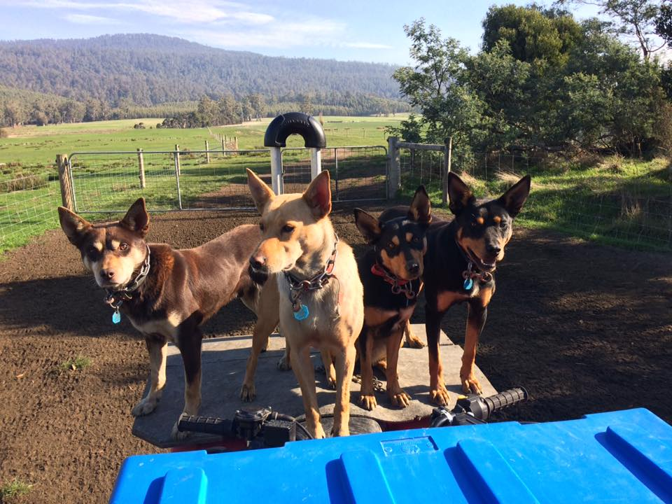
Pandara Kelpies
Brian Fish’s Bullock Team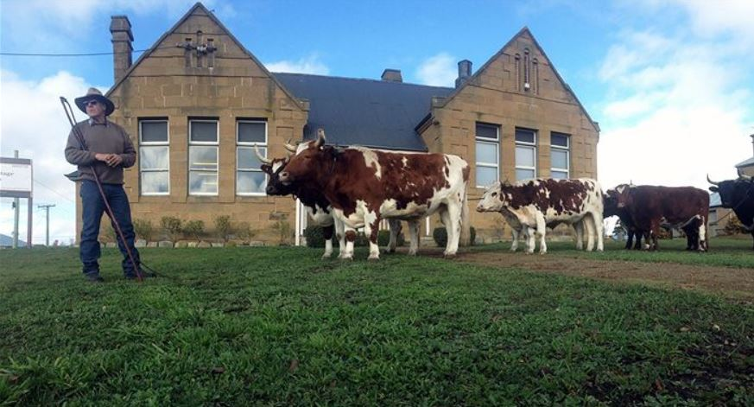

Introduction
The BBX Royal Hobart Show, which is hosted by the Royal Agricultural Society of Tasmania, is an event that celebrates all things Australian. From our country heritage to the charms of our bustling city and from top level competition to the latest in entertainment, the show offers something for everyone.

For many years school students from the city and country have been visiting the Show to soak up the sights, sounds and smells of rural Australia. The Show offers a unique hands-on learning experience for people of all age groups who can take advantage of the many educational experiences. This year is our 198th year of showing, the first Hobart Show was held on the lawns near the current Parliament House in 1822.

Please read this Teachers Guide and then feel free to contact us with any questions you have about bringing your school group to the Show.

When is the Show?  Wednesday 23rd October 2019  Thursday 24th October 2019  Friday 25th October 2019  Saturday 26th October 2019 | How to Contact the Show  Telephone: (03) 6272 6812  Facsimile: (03) 6273 0524  Email: admin@hobartshowground.com.au  Internet: www.hobartshowground.com.au
Where is the Show?  Hobart Showground, 2 Howard Road Glenorchy | Opening Hours  Wed 23rd 10.00am – 3.00pm  Thur 26th 9.00am – 5.00pm  Fri 27th 9.00am – 9.30pm  Sat 28th 9.00am – 4.00pm

Teachers Guide also available online: http://www.hobartshowground.com.au/show/education/index.php

Discount Entry Fees for School Groups
Discount entry to the BBX Royal Hobart Show is for students and accompanying teachers from schools. Students will pay only $3.50 with accompanying teachers and supervising adults free. A student/teacher ratio of 1:4 applies. Please note additional carers are allowed for special needs situations but please discuss with us prior to arrival.

Book now for a great day for everyone!
Fill out the Application Form on page 26 and return it to the BBX Royal Hobart Show by Monday 14th October 2019. A letter of entry will be forwarded to your school allowing access through the gates. An invoice will be issued to the school or payment can be made at the gates.

Further Information: Debbie Emmerton on (03) 6272 6812 between 1.00pm and 5.00pm weekdays. Email: debbie@hobartshowground.com.au

Competitions suitable for school children 

Youth Art & Student Photography
- $500 cash prize for the overall winner plus entry into 2020 Emerging Artist competition.
- Discounted entries for class groups are now available.
- Prize money ranging from $20 - $50 for individuals in each section.
- There are six (6) sections covering all grades available in Youth Art that are more closely aligned to appropriate age groups.
- Student Photography now divided into Primary & Secondary.
- Categories cover Open Mono Print, Inspired by Agriculture & Open Colour Print.

Artery Art on Show – Emerging Artist Competition
- Back by popular demand is the Emerging Artist Competition – which is an innovative award originally initiated by RAST in 2016. The encouragement based award aims to give artists aged 16 year of age and upwards assistance towards extending their skills in any chosen medium. Works up to 2 years old accepted (conditions apply).
- Young, appropriately aged artists can enter the youth based competitions as normal and if the standard of their work is considered exceptional by the expert panel of judges it could be automatically accepted for entrance in this new award.
- RAST fully encourages teachers to encourage students in the age range to get involved in this new, exciting competition.
- Over $10,000 in prizes overall up for grabs.

Homecrafts
- Dedicated youth section and schedule.
- Many opportunities for school children to enter ranging across categories including baked products, sweet products, Lego, craft, tapestry, cross stitch, wooden articles and many more.
- Wearable Art Competition - Individually designed pieces of handmade clothing created as a fine or expressive art. Artists may use purchased or handmade materials making them into unique garments & may dye & paint natural fibres. Design, construction & presentation will be the criteria for this exciting new section. Must have own mannequin. 1st Prize for the competition is $30.
- The overall school winner in the Homecrafts section wins the Shoobridge Shield ($500 for the school) each year which is one of the most prestigious awards at the Show. Get your entries in to give your school a chance of winning this highly sought after award.

Imagine the excitement of winning their first Show Ribbon and having the entries on display! Participation & encouragement ribbons issued in many categories.

Please see our website for details and schedules or contact the office for a copy.
www.hobartshowground.com.au

Curriculum ideas, web & Scootle links
Infant/Primary

Before the show
- Undertake a unit of work focusing on food or fibre production, farming, animal care.
- Read ‘Charlotte’s Web’.
- Undertake a unit on velocity (human cannonball).
- Read over the show guide and plan your tour.
- Make a list of 5 jobs that farmers do. Draw a piece of farming equipment and explain its purpose.
- Enter some of the many competitions designed specifically for students.
- Agriculture is all around us. As consumers, we depend on agriculture to provide food, clothes and other things we use every day. List some products that you use in your daily life that are produced from agriculture.

During the show
- Print out our Discovery Sheets from our website for the students to complete. Our stewards and volunteers will be ready to answer their questions.
- Have a go at completing the Hobart Show word search at lunchtime (found with our Discovery Sheets on our website)
- Interview someone about their handicraft. Ask 3 questions.
- Using the Hobart Show map, keep a record of where you visit.

After the show
- Draw a picture of an animal and its baby from the nursery.
- Describe your favourite animal at the show. If you were an animal what would you be and why?
- Match animals with their babies.
- Write a short summary or newspaper article of your day including the highlights.
- At the show you saw examples of agriculture. What did you see related to agriculture and consumers?
- Discuss the way weather impacts farmers and their crops.
- Tasmanian agriculture: what grows here? What do we export?
- Technology is used all around us. Compare sheep shearing now and in the past. How has technology changed the process of shearing?
- Research the history of the BBX Royal Hobart Show, Australia’s oldest show.
- Design a poster for the BBX Royal Hobart Show in 2027. What will the attractions be?
- Design and make your own show bag. Include a joke, a recipe, a puzzle, a calendar, a windmill, a chatterbox, origami, paper aeroplane, etc.
- Design a competition to attract show goers.
- Conduct a survey to find out who goes to the show.

Curriculum ideas, web & Scootle links
Scootle resources: (to support agriculture in the classroom)
Ref No. | Title | Year Levels | Key words
1145 | Food Chains: the farm | 4 | Farming
1147 | What is a food chain? | 3,4 | Farming
L26 | Old Bernie’s story | 2 | Farming, pond life
3455 | Green Valley Voice | 5 | Farming
10765 | Eco Farm | 6-10 | Farming
M013171 | Sustainable Agriculture |  | Agriculture
9314 | Eco House Challenge | 3-12 | Climate change
TLFIDL8186  IPad- M010736 | Students design their own talking dinosaur adding own text. | P - 3 | Dinosaur

Useful Web Links:
http://www.poultryhub.org/education/primary-secondary-schools/
http://www.poultryhub.org/?s=chickens+in+schools&x=0&y=0
Everything you need to know about chickens is available here including great resources that are available free. Also available are some excellent videos about raising chooks at school.


http://nswschoolanimals.com/

Very useful resources about keeping all sorts of animals in schools.

http://kb.rspca.org.au/Can-pigs-be-kept-as-pets_111.html
Can pigs be kept as pets?

Curriculum ideas, web & Scootle links
http://www.primezone.edu.au/school-resources/all-school-resources.html
 | Primezone provides teachers with single-point access to a range of primary industries education resources. This website is an initiative of the Primary Industries Education Foundation.
http://www.agclassroom.org/teacher/index.htm
 | About Agriculture in the Classroom  Agriculture in the Classroom programs are implemented by state-operated programs. National Agriculture in the Classroom supports state programs by providing a network that seeks to improve agricultural literacy — awareness, knowledge, and appreciation — among PreK-12 teachers and their students.
http://www.face-online.org.uk/

FACE (Farming & Countryside Education) is a charity which aims to help young people learn more about food, farming and the countryside.

http://www.theteachersguide.com/onthefarm.htm

 | The Teacher's Guide-Free worksheets, printouts, lesson plans, SMARTBoard templates, and more.

http://www.mpppaustralia.com/
Miniature Pigs and Pet Pigs in Australia | Information for budding pig owners in Australia

http://www.aglinks.com.au/   | http://www.alansfactoryoutlet.com/a-kids-guide-to-horses-and-barn-animals  A Kids Guide to Horses and Barn Animals

Curriculum ideas, web & Scootle links
Additional web links:
Meat and Livestock Australia www.mla.com.au
Food Connect http://www.foodconnect.com.au/
Food Wise http://foodwise.com.au/
Australian Chicken Meat Federation http://www.chicken.org.au/
Dairy Australia http://www.dairyaustralia.com.au/
Australian Pork http://australianpork.com.au/
Australian Eggs http://www.aecl.org/
Grain Growers http://www.graingrowers.com.au/
The story of stuff http://www.storyofstuff.org/
LandLearn NSW http://www.landlearnnsw.org.au/production-chains
Farmers Market Association http://www.farmersmarkets.org.au/
LandLearn NSW SlideShare http://www.slideshare.net/LandLearnNSW
CSIRO Farming and food production http://www.csiro.au/en/Research/Farming-food
Poultry CRC http://www.poultrycrc.com.au/
My American Farm www.agfoundation.org

Sustainable Environments
LandLearn http://www.landlearnnsw.org.au/sustainability/climate-change
Woolworths Sustainable Farming Program http://www.freshfoodfuture.com.au/fresh-food-future-stories/about.aspx
Australian Government Bureau of Meteorology http://www.bom.gov.au/climate/change/
NSW Government Climate Change website http://www.environment.nsw.gov.au/
CSIRO Sustainable Futures http://www.csiro.au/en/Education/Programs/Sustainable-Futures
Climate Kids (NASA) http://climate.nasa.gov/kids/
Teaching climate change http://www.teachclimatechange.org/

Show Features 2019
Alpacas FREE
Map Ref C2 – Alpaca / Sheep Pavilion
(Friday & Saturday only with a display on Friday and competition Saturday)

Alpacas are social herd animals and should always be kept with others of their kind, or at the very least with other herd animals. They are gentle, elegant, inquisitive, intelligent and observant. As they are a prey animal, they are cautious and nervous if they feel threatened. They like having their own space and do not like an unfamiliar alpacas or humans getting close, especially from behind. They warn the intruder away by making sharp, noisy inhalations, putting back their ears, twisting their heads and necks backwards toward the perceived threat, screaming, threatening to spit, and eventually may spit and kick. Due to the soft pads on their feet, the kicks are not as dangerous as those of hoofed animals.

A native of South America, the alpaca is a domesticated member of the Camelid family which includes the llama, camel, dromedary, guanaco and vicuna. Australia has the largest population of alpacas outside of South America. Approximately 40,000 alpacas are registered in Australia.

A number of alpaca fleeces are displayed at this year’s BBX Royal Hobart Alpaca Show. Alpacas are shorn once a year, usually in spring. Fleece weights range from 2-5kg and are valued according to their micron and silky feel.


Animal Nursery FREE
Map Ref C2 – Animal Nursery
The Animal Nursery is by far the cutest part of the show and it’s not every day we get a chance to get up close and personal with the many different animals on display. We have a variety of baby animals, and their mums, including sows and piglets, cows and calves, as well as ducklings, chickens, cavies (guinea pigs) and even sea-horses, reptiles and other aquarium dwellers!

Visit the Patting Pen for a hands-on area in the Nursery where children can meet, stroke, cuddle, hold and talk to some of these friendly little animals.

There’s even a hatching display, so come along and watch some of these little babies come into the world for the first time! Plus, you can have your picture on the front page of the Mercury newspaper at the photo stall inside the Nursery (cost $3).

Look out for Reptile Rescue and an array of snakes and lizards in here as well. The snake handlers will be conducting educational talks so check the program for times.

WARNING: Touching and petting of animals is considered high risk for PREGNANT WOMEN; CHILDREN UNDER 5; and those who are IMUNO DEFFICIENT. Contact should be avoided and hands washed if contact occurs. All others should wash hands as a precaution.

Show Features 2019
Artery Art on Show FREE
Map Ref D2 – Fine Art Pavilion (Under Main Grandstand)
Now open to all artists, amateur and professional of any age. Amateur artists have an excellent record of winning this event so we no longer separate them, anyone can enter. Prize money has also been increased thanks to the generosity of Artery with over $10,000 in prizes on offer.

The Royal Hobart ‘Art on Show’ attracts more than 200 entries each year. The art reflects the creative skills of the Tasmanian community both urban and rural. A wide range of traditional and abstract styles will be on display covering works in oil, acrylic, water colour, mixed media and pastel.

Check out the Youth Art exhibit to be able to see the work of students in two & three dimensional form, also in the Artery Art Pavilion. ENTER NOW

Beef Cattle FREE
Map Ref D1 – Dairy / Beef Cattle Pavilion
Cattle first came to Australia on the First Fleet in 1788. The cattle did poorly in the tough Australian conditions so different breeds from Europe, including Shorthorn and Hereford, were transported to Australia to improve quality. The majority of beef cattle in Australia are low in fat but high in iron which promotes strong and healthy young people.

Beef cattle handlers use a stick called a ‘Show Cane’. This is used to help position the cattle’s feet so they have the correct stance and then to tickle or scratch them to keep them still and quiet while they are being judged. They are never used to harm an animal.

A Junior Beef Cattle Handling competition will take place on Friday morning , in the afternoon on Friday the Junior Beef Cattle judging will be at 1pm. At 9am on Saturday the Junior Beef Handling Competition will be held for all those interested. The Cattle Fancy dress will follow the Junior Judging & Handling on Friday at 2.30pm.

2019 will see a resurgence in our school beef cattle exhibits thanks to some hard work from a very enthusiastic committee. Expect to see some exhibitors that have not shown for many years. We look forward to another huge beef cattle exhibit.

Those cute hairy Highland Cattle will be back as well.

Angus Cattle are celebrating 100 years in Australia this year and will be our feature breed. Angus is the most widespread and keenly sought after temperate beef breed in the world. This popularity is due to the greater profitability achieved by using Angus compared to other breeds.

WARNING: Touching and petting of animals is considered high risk for PREGNANT WOMEN; CHILDREN UNDER 5; and those who are IMUNO DEFFICIENT. Contact should be avoided and hands washed if contact occurs. All others should wash hands as a precaution.

Show Features 2019
Bulls and Barrels Rodeo Event FREE
Map Ref D3 – First National Arena – Fri evening only

The first Rodeo event of the 19/20 season will happen on Friday night on the First National Arena. A spectacular event showcasing the very best of Tassie’s cowboys and girls and the magnificent horses. Be in awe at the skills of these men & women as they drive these bulls around the circuit on our First National Arena.

Butchery Display FREE
Map Ref B3 – Tas Tafe Butchery School – Thursday only

Visit the TAFE butchery school to learn about various cuts of meat and how they are prepared. This is a fully fledged butchery and teaching facility right here on the grounds and the teachers will provide an insight into the trade and where various cuts of meat originate. Do you know the difference between rump and loin? Now you can find out.

Cats FREE
Map Ref C2 – Cats (Under Main Grandstand at Rear)
(Thursday [Judging] & Saturday only [Display])

This is an ever popular exhibition of our furry feline friends. A large variety of expertly manicured and groomed felines will be on display with judging occurring on Thursday and a display on Saturday.

FAST FACT: Despite being solitary hunters, cats are a social species and cat communication includes the use of a variety of vocalizations (mewing, purring, trilling, hissing, growling and grunting), as well as cat pheromones and types of cat-specific body language.

Cattle Fancy Dress – Friday only FREE
Map Ref D2 – Dairy Judging Ring

This year we will also feature a cattle ‘dress-up’ day on Friday at 2.30pm. The younger handlers in the sheds will be outfitting the beef and dairy cattle in fancy dress and parading them for the enjoyment of all. Prizes will be awarded and we expect this event to become extremely popular with the showgoers.

Cavies - also known as Guinea Pigs FREE
Map Ref C2 –Cavy Pavilion
This year there will be over 50 different classes of cavies to be judged in seven different groups including satin, crested and longhair. Popular breeds such as Himalayan, Abyssinian, Dalmatian and

Show Features 2019
Texel will be judged in the Rabbits / Cavies Pavilion on Saturday. There will also be a pet competition including a fancy dress and guinea pig races.

Cavy is another name for the guinea pig. It is derived from their Latin name, Cavia Porcellu. They originally came from the Andes (Peru, Bolivia, and Ecuador) where they have been domesticated for around 5000 years. They were brought to Europe sometime in the 16th Century. Princess Diana, mother of Prince William and Prince Harry, had cavies as pets when she was young!

Charity Children’s Pageant FREE to watch
Map Ref D2 – Show Village Lawn – Friday only

Organised by Mr Diamond Australia, Jordan King, to raise money for the Royal Hobart Hospital Children’s Ward the pageant is open to ages 0 – 16 years with a range of prize vouchers on offer as prizes. $10 entry fee. The theme will be Agricultural Fun Fashion.

Dairy Cattle FREE
Map Ref D1 Dairy / Beef Cattle Pavilion

Dairying is another major Australian rural industry in which production significantly exceeds domestic requirements and Australia has emerged as one of the world’s major exporters of dairy products.

The history of Australian dairying dates back to the arrival of the First Fleet in 1788. The early dual-purpose Shorthorn cattle and goats provided the fledgling colony with much of its milk and meat
needs. The Jersey breed arrived towards the middle of the 19th century and the Holstein-Friesian was imported around 1850.

Dogs FREE
Map Ref A4 – Dogs
Over 600 dogs, covering 109 different breeds from all over Australia will compete for the coveted title of Best Dog in Show across the 4 days at the 2019 BBX Royal Hobart Dog Show, to be judged by an international judge from Norway.

Did you know that dogs are more than pets? Dogs can be professionals, just like humans. Many of them even have paid jobs! Dogs can work in airports, police stations and on farms. They protect us, save us, work for us, and give us unconditional love. They really are amazing creatures, and there are many different breeds for the different purposes we require them for.

Your task – visit the Dog section of the show. Find a dog that really interests you and try and find out more about it! Do dog owners really look like their dogs?

Show Features 2019
Ferrets FREE / NEW
Map Ref B5 – Ferret Shed Off VIP car park next Draught Horses

Yes – Ferrets will again feature at the 2019 Show after their success at the past three Shows. You must check out these furry little critters that have been an established part of our farming community since the early days of the colony. We promise they are all friendly and their handlers would love to tell you all about these amazing animals.

They will be competing this year just like all of our other animal exhibits. So come along and see if you can spot the Best in Show Ferret. There will also be ferret races throughout the Show so check the program for details.

Fleece FREE
Map Ref C3 – Admin Building (Adjacent to the Show Office)
The Fleece competition is a showcase of wool from all parts of Tasmania. Feel the different types of wool and find out what makes a good fleece. There is a display of wool spinning and some finely crafted and colourful woolen hand-made products.

The best fleeces in Tasmania as will be on display along with some samples that you can take with you.

Friday Night Entertainment FREE
Map Ref D3 – First National Arena from 5.00pm Friday Night
Friday Night at the Show has been a family tradition for many Hobart families for many years and this year’s program is sure to have something for everyone. With a program starting at 5.00pm the night will include Noah’s Racing Pigs, the Bulls and Barrels Rodeo event, the Bullock Team, the Human Cannonball, the Wheel of Steel, Taiko Drummers and the most popular act, the HIT 100.9 Friday Night Fireworks.

Come in early in the day and bring your family for a fun afternoon and night at the Show. Food and beverage available in the Cattleman’s Bar, upper level Main Grandstand (the best seat in the house).

Goats FREE
Map Ref E1 & C2 – Goats (Back of Brooker Pavilion E1 and Goat Pavilion C2)
Goats were among the earliest animals to be domesticated. Goat remains found in Asia tell us that this domestication happened between 6000 and 7000BC. Goat breeds can be classified into three different types – meat, dairy and fibre. Dairy breeds include Anglo-Nubian, British Alpine, Saanen and Toggenburg. Fibre breeds are Angora and Cashmere, while Boer is a meat breed.

Show Features 2019
Anglo-Nubian goats are considered the most popular. They originated in the United Kingdom as a result of cross breeding the British goat with the Egyptian or Indian descendants. Milk of these goats is ideal for cheese making because of its high butter fat content.

Homecrafts FREE
Map Ref E2 – Homecrafts Pavilion
One of the traditions of the BBX Royal Hobart Show is our Homecrafts Section (formerly known as the Creative Craft section). Far from being of casual interest and entertainment, this section has its origins in the need for the women of the Australian bush to be self-sufficient in the management of their residences and property.

This year we’ve continued to evolve the section in its’ new home, more prize money, and even more new sections in an effort to modernise our appeal and attract greater participation. One of these new sections will be the “Wearable Art Competition”. Wearable Art is an individually designed piece of
handmade clothing created as a fine or expressive art. Artists may use purchased or handmade materials making them into unique garments and may dye and paint natural fibres. Design, construction & presentation will be the criteria for this exciting new section. Must have own mannequin.

A major incentive for schools to enter in the Homecrafts section is the presentation of the Shoobridge Shield. The Shield is awarded to the best performing school in the Homecrafts section each year and is a highly valued prize both within the Show and in the school community and includes $500 prize money for the school that accumulates the most points.

Our Homecrafts committee is this year bringing back a café into the pavilion which will have scones, cakes and other delicious home-made treats available.

Here you are likely to see a huge variety of crafts including ceramics, folk art, beading, crochet, cross stitch, dolls, embroidery, glass, felting, knitting, lapidary, pottery, porcelain, spinning, sewing, textiles and cooking as well as new areas from calligraphy, carved and decorated eggs to pesto cookery and beading. ENTER NOW.

Horses FREE
Map Ref D3/4 – First National Arena
Over 250 horses and ponies will compete at the BBX Royal Hobart Show – a showcase of the finest! There are many different breeds of horse that compete at the Show for the sought after Blue Ribbon.

One of these breeds is the Australian Draught Horse. The Australian Draught Horse was developed over the years as a result of the crossbreeding of the four recognized pure draught horse breeds which were in Australia since the colonial days. These breeds are the Clydesdale, Percheron, Shire, Suffolk Punch, (plus the later imported Belgians) and occasionally some light horse bloodlines, as seen in the part draughts. The characteristics of these breeds can be found in the Australian Draught

Show Features 2019
Horse, which has produced many colours and types within the breed. All solid colours are accepted, excessive white is not favoured on the face or body, white below the knee is acceptable.

There will this year be a Draught Horse display for the duration of the Show located just inside the Howard Road entrance.

Human Cannonball FREE
Map Ref D3 – First National Arena
Blast off! Our performer is shot out from our specially designed cannon at over 75kph flying across the arena before landing safely into a net up to 40 meters away. With our performer experiencing up to 6G’s of force on take-off this act is sure to leave audiences on the edge of their seat! A true blast from the past of Show entertainment and something everyone should experience at least once. Only at the Royal Hobart Show.

Kids Activities Hub FREE
Map Ref C3/C4 – Kids Activity Area – First National Arena South
A new area for this year’s BBX Royal Hobart Show the Kids Activities Area will be home to a number of activities throughout the Show in particular activities run by Cricket Tasmania and the Hobart Hurricanes, Warriors Touch Football, Netball Tas, Dominic College, Air Force Cadets and Brighton Football Club. These groups will be bringing a range of activities and with a large amount of seating close by this is the perfect spot to sit for lunch while children have the chance to play their favourite sport or engage in one of the many activities.

Life on the Farm FREE
Map Ref E1 – Life on the Farm (At the back of the Brooker Pavilion)
The Life on the Farm display is the educational centre of the BBX Royal Hobart Show designed to introduce the urban community to the role of agricultural animals. Demonstrations to be held throughout the day include sheep shearing, bee keeping, chook washing, butter making and lots of free hands on activities for young people.

Miniature Horses FREE
Map Ref D1 – Beef Cattle Judging Arena – Saturday only

Super cute and small in stature but big on personality these little guys are competing just like their bigger cousins to be the best of the best at the Royal Hobart. They’ll have led classes, jumping and dress ups.

Returning to Hobart Royal for the second year by popular demand and a special treat for our Saturday patrons.

Show Features 2019
Noah’s Thoroughbred Miniature Racing Pigs FREE
Map Ref D2 – Show Village Lawn – Food Hub

Noah’s Thoroughbred Racing Pigs is entertainment at its best. Fun filled enjoyment for all ages.
From the bugle race call, through the obstacles, to the last snout in the finishing trough, crowds will be cheering their preferred pig to the end.

Noah’s Thoroughbred Racing Pigs have been entertaining Australians for over a decade, travelling all over Queensland, New South Wales & Victoria. Always a crowd favourite.

Pandara Kelpies FREE
Map Ref C4 – First National Arena South
Matthew Johnson demonstrates how intelligent and well trained his yard dogs are around the farm. This entertaining and insightful show provides an insight into how working dogs make such a difference on a farm. This popular show has been at Agfest and now comes to Hobart for the second time by popular demand.

Pigs FREE
Map Ref C2 – Animal Nursery
The ever popular pigs are back again this year. Housed in the ever popular Animal Nursery the pigs will be easy to find this year.

Poultry & Caged Birds FREE
Map Ref C1 – Poultry and Canaries
Poultry displays have taken place at the BBX Royal Hobart Show for more than 150 years. The Poultry Pavilion usually features more than 650 birds. Judging will commence on the Wednesday for poultry, pigeons, and canaries.

Breeding & exhibiting show poultry is a hobby followed by people all over the world from all walks of life and ages. Breeders look for 3 things in showing poultry – Condition (overall fitness and sound plumage); Colour; and the shape of the bird (does it conform to the type of bird).

The North versus South Rivalry continues this year with the Northerners keen to redeem their losses of the first 2 years. Celebrity judge, Triple M’s Dave Noonan returns and will determine which end of the State presents the best poultry exhibits this year. Action starts at 10.00 am on Saturday and the winners will take away the highly sought after RAST certificate and bragging rights for the next 12 months.

Show Features 2019
Reptile Rescue FREE
Map Ref C2 – Animal Nursery
Snakes and lizards galore! One of our most popular exhibits is back again this year. Learn about handling snakes, which ones are venomous and get a close up look if you dare. Educational talks and demonstrations will occur throughout each day so check our program for exact times.

Sheep FREE
Map Ref C1 – Sheep / Alpacas Pavilion
Wednesday, and Thursday only
Sheep are an extremely valuable part of Australia’s agricultural industry, and the economy. They provide us with food and clothing. The BBX Royal Hobart Show presents many different breeds of sheep, most bred for a specific purpose (either wool or meat) and to benefit us as consumers.

Show Village Lawn – Food Hub FREE
Map Ref C2/D2 – Show Village Lawn
A family friendly hub on lawn in front of the new poultry pavilion. Plenty of traditional show fare, activities for the kids, seating to enjoy the food on offer form a selection of Hobarts finest street eats.

A great place to relax, put your feet up and enjoy some good old fashioned show fare. The lawn will also this year play host to the Racing Pigs Show which is sure to be a hit with children of all ages and the Boy / Girl Pageant on Friday.

Seven Tas Lawn FREE
Map Ref C3 –Seven Tas Lawn

The Seven Tas Lawn is one of the most popular places to visit at the Royal Hobart Show. Home to a number of kids activities run by HIT 100.9, Triple M Hobart and Seven Tas as well as being the place to meet your favourite Triple M and Hit FM personalities. Keep an eye out throughout the Show for the chance to meet Dave Noonan and Al Plath or the famous “Marls” eating a pie and even Dangerous Dave.

The lawn is also home to the amazing “Be a Weather Presenter” display which allows children to star in a real life TV weather set.

WARNING: Touching and petting of animals is considered high risk for PREGNANT WOMEN; CHILDREN UNDER 5; and those who are IMUNO DEFFICIENT. Contact should be avoided and hands washed if contact occurs. All others should wash hands as a precaution.

Show Features 2019
Static Monsters – Strongman Competition FREE
Map Ref D2 – First National Arena North
A strongman competition with a difference. Not your average weight lifting competition as this is a bit different. Part of an international sport anyone can have a go if they are strong enough. Guaranteed to be a great spectacle. Saturday only.

The Static Monsters is now the biggest strongman event of its kind in the world and will continue to grow. It gives new athletes the opportunity to try competing for the first time without the barrier of having to learn too many events. it also gives experienced athletes some goals to compete for as well as being able to compete against the best athletes in the world all under the same conditions and rules despite being separated by vast distances.

Tasmanian Draught Horse Association FREE
Map Ref A5 – Howard Rd Gate Lawn
These timeless horses will on display again just inside the Howard Rd gate. Stop and have a pat, get your photo taken with them and learn about the significant contribution they made to the establishment of agriculture in the early colony of Hobart.

Tasmanian Government Pavilion FREE
Map Ref D2 – Government Pavilion, under Main Grandstand
The Tasmanian Government returns after a 5 year absence with an interactive display covering primary industries, emergency services, health and many other areas. Come along and engage with our State’s professional public servants, have some fun, and learn a thing or two about what our State Government can do for you.

Vintage Cars FREE
Map Ref D2 – Family Fun Area

Always a favourite these old time cars are in a new location this year just outside the Artery Fine Art and Food Pavilion.

Vintage Machinery and Transport FREE
Map Ref B5 & E2 – Inside the Brooker Gate E2 and also just off Main Drive inside Howard Rd gate B5
Traditionally a feature exhibit at the BBX Royal Hobart Show, the Vintage (Heritage) Machinery and Transport areas present more than one hundred individual items of vintage machinery, all of which have been integral to Tasmania’s agricultural development. Look out for this year’s theme to be announced closer to the Show. There also a display of vintage cars.

Show Features 2019
Virtual Reality – VR Farm FREE
Map Ref E2 – Old CWA Building

Experience a real working farm environment in virtual reality with the latest technology and some high level production to underpin it. Pull on the goggles and you’ll think you’re actually there. Be careful not to fall off the tractor though. Only at the Royal Hobart Show.

Wheel of Steel FREE
Map Ref D3 – First National Arena

The Wheel of Steel is a thrilling performance where the performer runs, skips and executes acrobatics whilst running in a rotating steel pendulum that reaches a height of 11 metres. This high adrenaline act is performed without the aid of safety nets or wires, making it a truly on the edge of your seat experience. Only at the Royal Hobart Show.

Whipcracking FREE
Map Ref D2 – Dairy Judging Ring (Saturday only)

After a great inaugural event in 2016, the Tasmanian Whipcracking Championships will be held as part of the Royal Hobart Show for the second time. There will be 8 sections including Novice, Pee Wee, Juvenile, Junior, Ladies, Men's and Over 45's. The Australian Whipcrackers & Plaiters event is very focused on preserving our Australian culture and heritage and all members must compete in a professional way and also dress accordingly. Competitors will be awarded up to 10 points, from either of the 2 judges, for presentation and Australian dress.

Woodchopping FREE
Map Ref C3 – First National Arena (Thursday, Friday & Saturday only)

A long standing tradition for any Royal Show is the woodchopping carnival. The woodchop arena will again be located on the First National Arena to enable even more people to enjoy the carnival with undercover seating available in the Old Grandstand.

There will be a full program of activities over three days from Thursday including men’s, women’s and team events. Also back by popular demand is the 5th Celebrity Wood Chop competition featuring local media personalities and politicians.

WARNING: Touching and petting of animals is considered high risk for PREGNANT WOMEN; CHILDREN UNDER 5; and those who are IMUNO DEFFICIENT. Contact should be avoided and hands washed if contact occurs. All others should wash hands as a precaution.

Show Features 2019
Woodcraft Guild of Tasmania Junior Woodcraft FREE
Map Ref E2 – Junior Workshop (Rear of Homecrafts Pavilion)
Enabled by the generosity of the members of the Woodcraft Guild of Tasmania who will conduct woodcraft activities for children to appreciate and experience the art of woodcraft. It is for kids only. Participants will construct a pre-fabricated item and glue, screw and nail it together. The kids get to keep their work and it’s free.

Youth Art & Student Photography FREE
Map Ref D2 – Fine Art & Food Pavilion
A new home, more space and better combination of youth art and student photography again for 2019. As Art on Show has moved to the Main Pavilion, Youth Art has expanded and moved with it. A must see for those curious to see what Hobart’s young artists are producing and those looking for inspiration from the millennials.

A major feature of the Youth Art & Student Photography section this year will be our Black & White Photography competition. This is an extremely popular competition and is a must enter for any student looking to show their photos for the first time. Check out the Youth Art & Student Photography section for further details. $500 cash on offer for the ‘Best in Show’.
ENTER NOW.
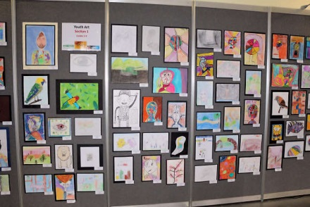

Survival Guide 2019
Hint: We suggest teachers take this Guide plus a copy of the Show Map with them on the excursion.

Transport
- Charter Buses – NOTE: the Knoll St drop off is no longer available (a map will be supplied with your entry tickets and is included with this kit)
- Park at car park on corner of Goodwood Rd and Brooker Highway next to the fire station, access via Acton Crescent. Access to the show is across the Brooker Highway via the pedestrian crossing covered by traffic lights. Buses may park all day in this car park for free.
- Drop off students and teachers at the Bus Stop 23 on Main Rd opposite Cosgrove High School and proceed through the alleyway next to the old Tile Shop to the front gates of the Showground. Bus to then proceed to the car park. Pick up can also be done from here. Buses must be travelling south toward the city from Glenorchy to utilise this bus stop.
- Metro Bus – general information line 13 22 01
- Car – parking available
- on the corner of Brooker Highway and Goodwood Road – entrance off Goodwood Road
- Racecourse – entrance off Goodwood Road to be confirmed
- Disabled drop off - near Howard Rd gate with limited parking but bookings essential

Entry Gates (Map Ref A6, E2)
Main entrance for school students will be through the main gates on Howard Rd, Map Ref A6. Entry from the car park is through the Brooker Highway gates, Map Ref E2, students will need to cross at the traffic lights to gain entry to the Showground.

Respite Areas
The best places to sit down as a group and either eat lunch or just have a rest are:-
- Seven News Lawn area in front of the Administration Building overlooking the First National Arena (Map Ref C3)
- Main Grandstand providing indoor cover and plenty of seating upstairs and downstairs (Map Ref D2)
- Showcase Lawn (Map Ref A5)
- Old Grandstand providing undercover seating and shade (Map Ref C3/D3)
- Showcase Pavilion, indoors with entertainment (Map Ref A4)
- The Show Village Lawn and Food Hub (Map Ref C2/D2)
- The Activities Hub on the First National Arena (Map Ref…….

Public Telephones
There are no Public Telephones on the Hobart Showground. In an emergency please call into the Information Centre or Police Office located near Administration Building or contact Show staff.

Survival Guide 2019
ATM Facilities
This year you will find one ATM located in the Showbag Pavilion near the Howard Road Entrance (Map Ref A4), and others near the Show Village Lawn/ Food Hub (Map Ref E2).

Toilet Facilities
There are numerous toilet facilities located around the Showground. Please refer to the map for specific locations.

First Aid
You will find the St John First Aid Station at the top of Showground Drive near the Information Centre. (Map Ref B3). In case of an emergency contact Show staff, security or Police.

Police
The Police Station is located next to the St John First Aid Station at the top of Showground Drive near the Information Centre. (Map Ref B3)

Lost Students
It’s probably the thing that keeps Police the busiest on the days that student groups come to the Show. The Police have asked that you simply pen teacher’s mobile number on their wrist or make sure they are carrying a piece of paper with the best contact number. All lost children will be handed over to Police at the first available opportunity and will be cared for at the Police Station (Map Ref B3).

Lost Persons Centre
If you lose each other in crowds, the best place to go is the Lost Persons Centre, located in the Police Station (Map Ref B3).

Lost Property
Please report all lost property or theft to the Police located at the top of Showground Main Drive near the Information Centre. (Map Ref B3).

Excursion Hints
- Students should wear some form of school identification. With younger students this identification should include the mobile phone number of a supervisor in case the student gets separated from the group. We do not recommend that this identification include the name of the individual student.

Survival Guide 2019
- Bring on the excursion:
  - Confirmation of booking issued by the Schools’ Program Coordinator
  - Excursion Survival Guide (provided in this handbook)
  - Show Map
  - Sunscreen
  - Water
  - Hat
  - Wet weather gear
  - Comfortable shoes
  - Backpack or carry bag is useful for students to collect information and samples from exhibitors while at the Show

- Free water is available onsite at any café or bar area

- Animals on Display - Please be aware that some types of animals are not at the Show for the 4 days of the Show.

- Although many animals are domesticated, they can cause injury and should be treated with caution. The size and bulk of some animals can make them potentially very dangerous.

AVOID ACCIDENTS!
Please advise students to:
- Avoid quick movements or loud noises that may frighten the animals.
- Do not poke, tease or imitate the sound the animal makes.
- Beware of standing behind the animals, as livestock can kick forward, sideways and backwards.
- Only pat the animals if the owner is present and gives his or her permission. Wash hands afterwards.
- Move slowly in single file around livestock.
- Allow enough space between you and the animals to avoid being stepped on or kicked.
- Most animals tend to be aggressive when protecting their young. Be extra careful around newborn animals.
- Touch animals gently and don’t push or shove, but only when allowed to do so.
- Always wash your hands after touching animals. Hand washing facilities are located at the entry and exit points of animal pavilions.

More resources available at: http://www.hobartshowground.com.au/show/
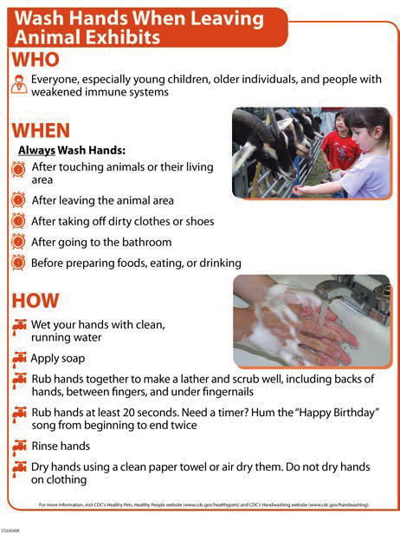
SHOW MAP still to be published
