What is the most common sheep breed in Australia?
M_ _ _ _ _ _
What features of this breed of sheep make it ideal for our conditions?
______________________________________________________________________________
Brainstorm some words to describe the feel of the fleece of the different breeds of sheep. Write them inside and around the sheep.
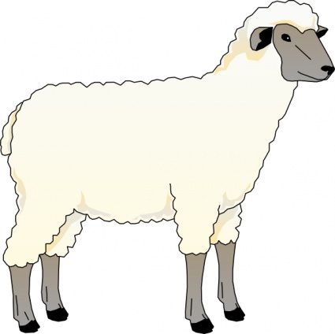
FAST FACTS
After shearing, the wool is taken to wool stores where it is spun and dyed and used for clothing, furnishings, fabric, carpets and even medical supplies
Sheep were brought to Australia with the First Fleet in 1788. The Australian wool industry is now one of the world’s biggest
The Merino is the most common breed of sheep in Australia. An average wether produces up to 5kg of wool each year

